DAY 3.2

1:Create Date Class with Data Members day,month, year

1.1:Create an object and initialize it using setDate methods and display it using

displayDate methods.

**package** Assignment_3_2;

**import** java.util.Scanner;

**public** **class** MAIN_Date {

**public** **static** **void** main(String[] args) {

Scanner sc = **new** Scanner(System.***in***);

Date d=**new** Date();

**int** ch = 0;

**do** {

System.***out***.println("\n1.Enter Date 2.Display Date 3.Exit");

System.***out***.print("\nEnter Choice:");

ch=sc.nextInt();

**switch** (ch) {

**case** 1: {

System.***out***.println("\nEnter Date in the format DD/MM/YYYY:");

d.setDay(sc.nextInt());

d.setMonth(sc.nextInt());

d.setYear(sc.nextInt());

**break**;

}

**case** 2:

{

d.display();

**break**;

}

**case** 3:

System.***out***.println("---Program Terminated Successfully---");

**break**;

**default**:

System.***out***.println("\nEnter a valid value!!!");

}

} **while** (ch != 3);

}

}

**package** Assignment_3_2;

**public** **class** Date {

**private** **int** day, month, year;

**public** **void** setDay(**int** day) {

**this**.day = day;

}

**public** **void** setMonth(**int** month) {

**this**.month = month;

}

**public** **void** setYear(**int** year) {

**this**.year = year;

}

**public** **void** display() {

System.***out***.println("\nDate :"+day+"/"+month+"/"+year);

}

}

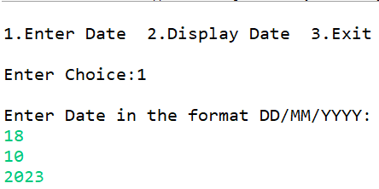

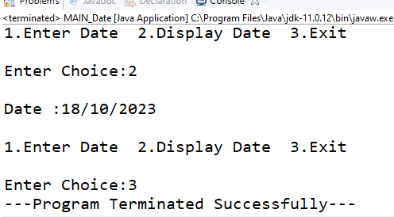

--------------------------------------------------------

2:Create Student Class with RollNo,name,totalMarks and Grade

.Create an object and initialize it using assignStud method and print it using

printStud method. Create Object of the student and call Methods

**package** Assignment_3_2;

**import** java.util.Scanner;

**public** **class** MAIN_Student {

**public** **static** **void** main(String[] args)

{

Student s1=**new** Student();

Scanner sc=**new** Scanner(System.***in***);

System.***out***.println("Enter Student Details:-");

System.***out***.println("Roll Number,Name,Total Marks out of 500,Grade");

s1.assignStud(sc.nextInt(), sc.next(), sc.nextDouble(),sc.next().charAt(0));

System.***out***.println("\nStudent Details:-");

s1.printStud();

}

}

**package** Assignment_3_2;

**public** **class** Student {

**private** **int** roll_no;

**private** String name;

**private** **double** total_marks;

**private** **char** grade;

**public** **void** assignStud(**int** roll_no,String name,**double** total_marks,**char** grade)

{

System.***out***.println("---assignStud Method Invoked---");

**this**.grade=grade;

**this**.name=name;

**this**.roll_no=roll_no;

**this**.total_marks=total_marks;

//System.out.println("as"+total_Marks);

}

**public** **void** printStud()

{ System.***out***.println("\n---Invoking printStud Method---");

System.***out***.println("\nStudent Details:-");

System.***out***.println("\nName :- "+name+"\nRoll Number :- "+roll_no+"\nTotal Marks :- "+total_marks+"\nGrade = "+grade);

}

}

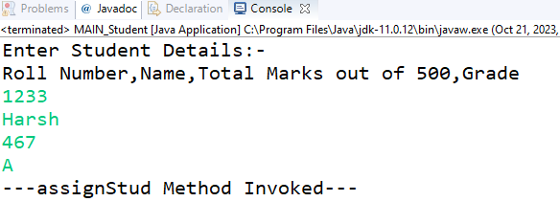

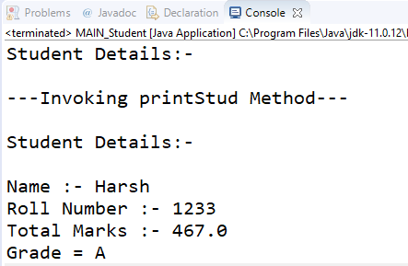

-------------------------------------------------

3:Create java application for bank account handling.

3.1. Create a class BankAccount -- acct no(int),customer name(string),balance(double)

constr to accept all details

3.2 Add Business logic methods

Methods

public void withdraw(double amt)

public void deposit(double amt)

3.3:Create TestAccount class...Create object of account class and test withdraw and deposit methods.

**package** Assignment3_3;

**public** **class** Bank {

**private** **int** acc_no;

**private** String cust_name;

**private** **double** bal;

**public** Bank(**int** acc_no, String cust_name, **double** bal) {

System.***out***.println("------Initial Detils-----");

**this**.acc_no = acc_no;

**this**.cust_name = cust_name;

**this**.bal = bal;

}

**public** **void** withdraw(**double** amount) {

System.***out***.println("\n----Withdraw Method----");

bal=bal-amount;

System.***out***.println("Debited Successfully!!!");

}

**public** **void** deposit(**double** amount) {

System.***out***.println("\n-----Deposit Method----");

bal=bal+amount;

System.***out***.println("Credited Successfully!!!");

}

**public** String toString() {

System.***out***.println("\n----Account Details----\n");

**return** "\nAccount Number :- "+acc_no+"\nCustomer Name:- "+cust_name+"\nBalance:- "+bal;

}

}

**package** Assignment3_3;

**import** java.util.Scanner;

**public** **class** Tester {

**public** **static** **void** main(String[] args) {

Scanner sc=**new** Scanner(System.***in***);

Bank b1=**new** Bank(1234,"Harsh",10000.00);

System.***out***.println(b1);

b1.withdraw(4500);

System.***out***.println(b1);

b1.deposit(4566);

System.***out***.println(b1);

}

}

